**PCB Design of Top Layer**

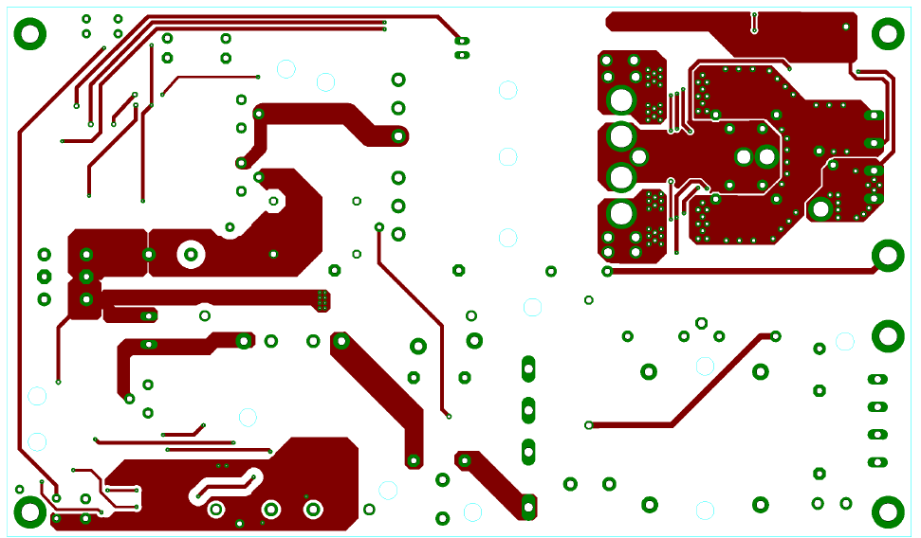

**PCB Design of Bottom Layer**

