How to Flash M0+ Dedicated to BLE
The Semtech LoRa Edge Tracker Reference Design already has a BLE stack programmed into the M0+ core. However, if for some reason the stack needs to be reprogrammed or updated, here are the steps to follow.
- Install STM32CubeProgrammer:
- Install the STM32WB Cube Package:
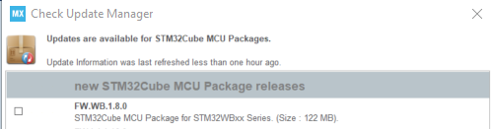
Figure 29: Install STM32WBxx Package
Once installed, the necessary .bin file(s) are in the following folder:
C:\Users\...\STM32Cube\Repository\STM32Cube_FW_WB_V1.8.0\Projects\STM32WB_Copro_Wireless_Binaries\STM32WB5x
Copy and paste the .bin file(s) into the STM32CubeProgrammer bin folder:
C:\Program Files\STMicroelectronics\STM32Cube\STM32CubeProgrammer\bin
- Switch the STM32WB55 to bootloader mode
  - Maintain the BOOT0 pin in high level while the tracker is resetting
  - Connect STM32WB55 USE lines to a computer/laptop
- Open a Command Prompt window
  - Navigate to the STM32CubeProgrammer bin folder:
cd C:\Program Files\STMicroelectronics\STM32Cube\STM32CubeProgrammer\bin
- Delete the existing firmware:
STM32_Programmer_CLI.exe -c port=usb1 –fwdelete
- Read and upgrade the FUS version:
STM32_Programmer_CLI.exe -c port=usb1 -r32 0x20030030 1

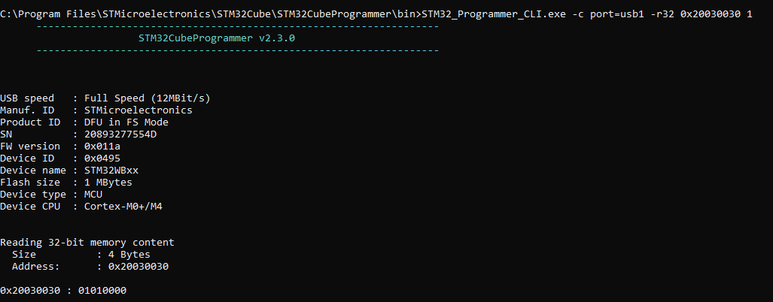
Figure 30: Check FUS Version
If the FUS version is as follows, install the stack firmware:
0x20030030: 00050300: FUSv0.5.3:
STM32_Programmer_CLI.exe -c port=usb1 -fwupgrade stm32wb5x_FUS_fw_1_0_2.bin 0x080EC000 firstinstall=0
0x20030030: 01000100 or 01000200: FUSv1.0.x
STM32_Programmer_CLI.exe -c port=usb1 -fwupgrade stm32wb5x_FUS_fw.bin 0x080EC000 firstinstall=0
0x20030030: 01010000: FUSv1.1.0 => Up to date
Command to install the stack firmware:
STM32_Programmer_CLI.exe -c port=usb1 -fwupgrade stm32wb5x_BLE_Stack_full_fw.bin 0x080CB000 firstinstall=1

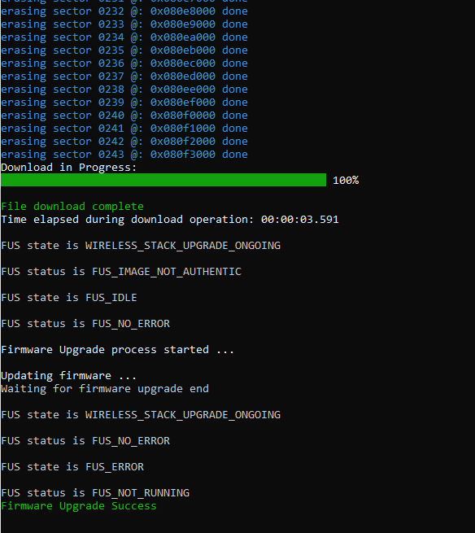
Figure 31: Flash BLE Stack Firmware
文件出至Semtech Develop Website
https://lora-developers.semtech.com/library/tech-papers-and-guides/lora-edge-tracker-reference-design-user-guide/tracker-software-overview/

