‧特性數據
Efficiency vs. Line
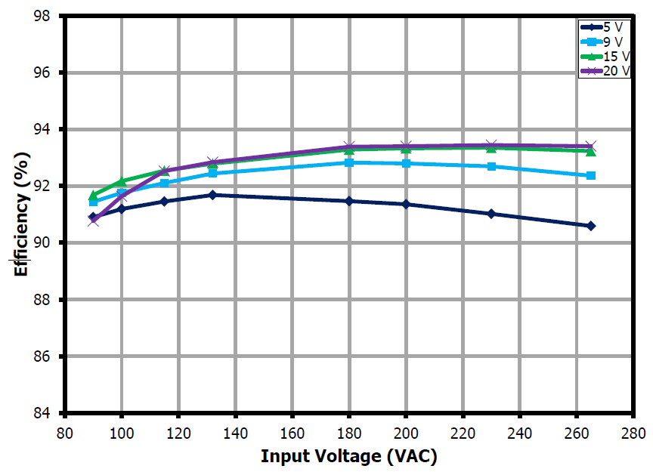
Average Efficiency
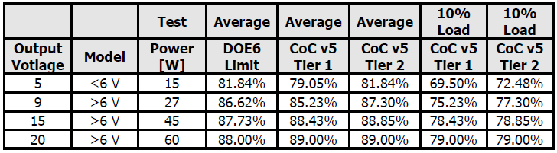
Average and 10% Efficiency at 115 VAC Input
VOUT = 5 V VOUT = 9 V
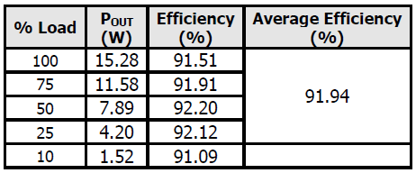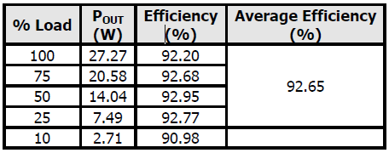
VOUT = 15 V VOUT = 20 V
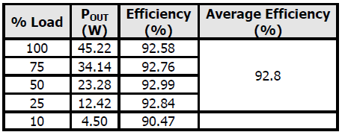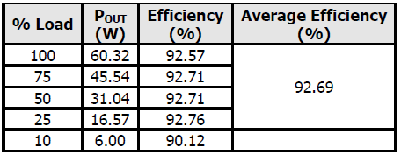
Average and 10% Efficiency at 230 VAC Input
VOUT = 5 V VOUT = 9 V
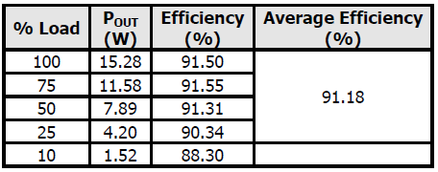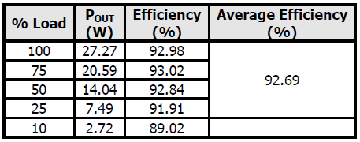
VOUT = 15 V VOUT = 20 V
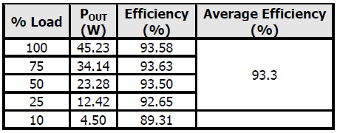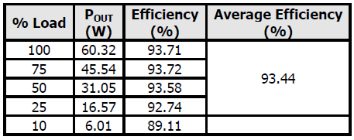
VOUT = 20 V

CV/CC
VOUT = 5 V VOUT = 9 V
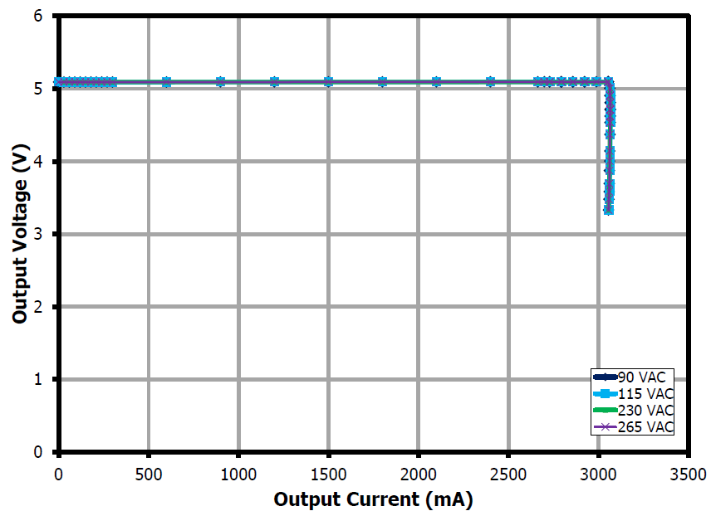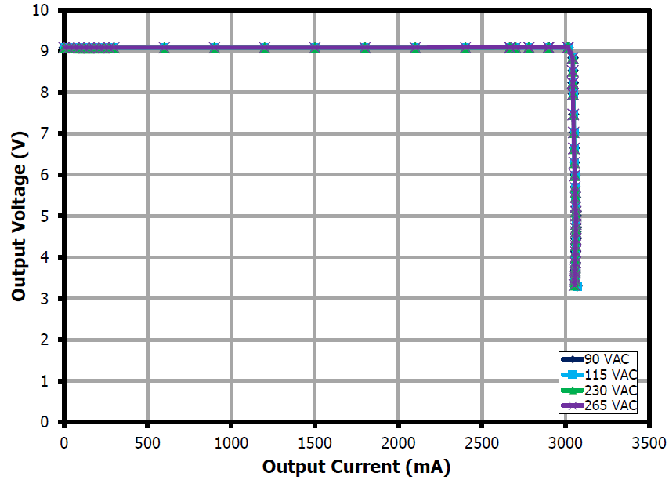
VOUT = 15 V VOUT = 20 V
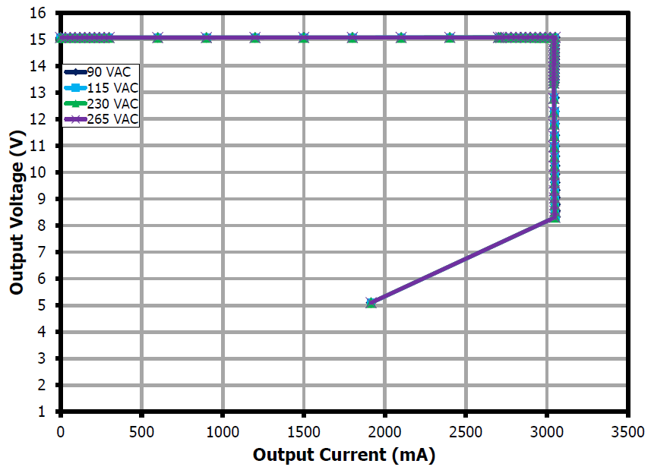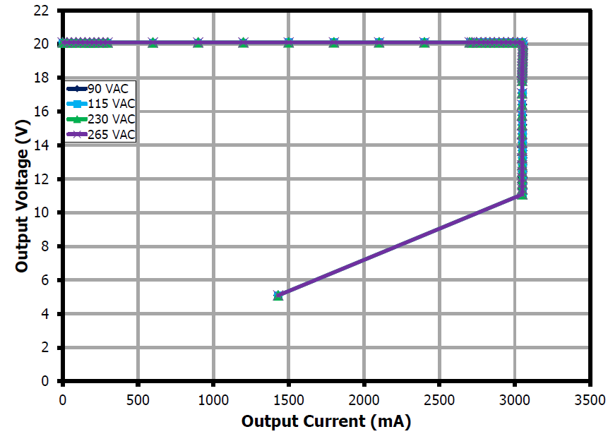
Thermal Performance
90 VAC Input 20 V, 3 A at 26.1 ºC Ambient 90 VAC Input 20 V, 3 A at 45.2 ºC Ambient
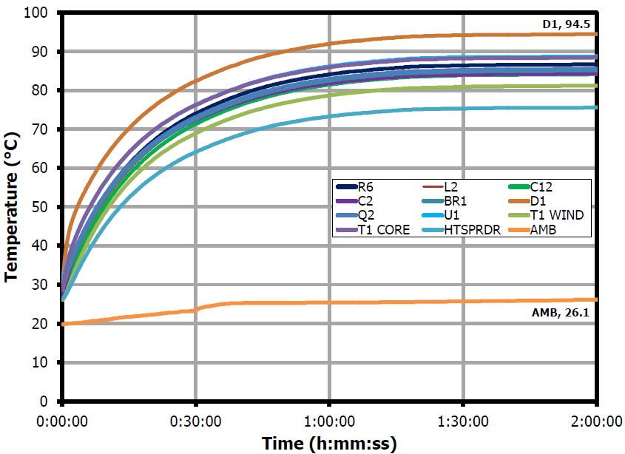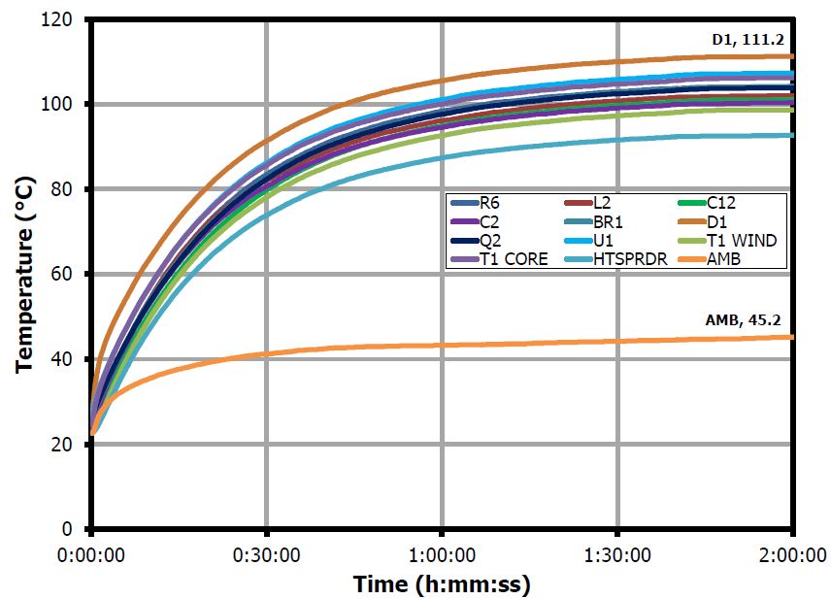
115 VAC Input 20 V, 3 A at 45.2 ºC Ambient 265 VAC Input 20 V, 3 A at 42.9 ºC Ambient
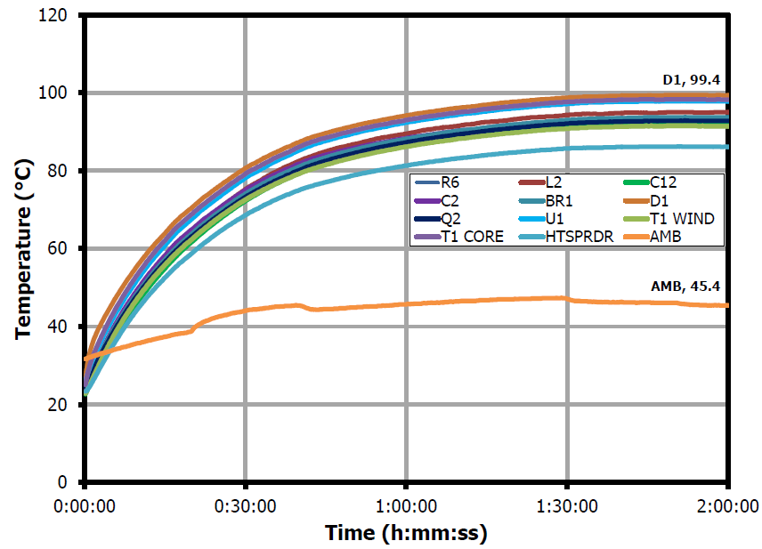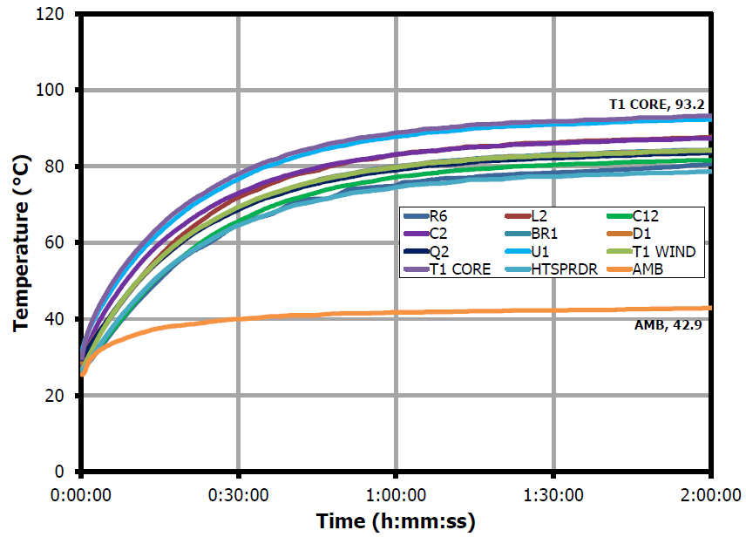

Load Transient Response (On the Board)
